8th Grade Machines Project:

- Group of 4 partners
- 5 Minute Class Presentation
- 1 page paper
- Use up to 4 sources provided in class
Each student will be responsible for his or her participation. A participation rubric will be provided to grade each person in the group (10 points). The presentation must include how the machine works, type of machine (etc. levers, wheel and axle, pulley). A grading rubric is attached to see what each part of the project will be worth. In your paper you will write it as the example provided in this packet. This will count as your test grade for this chapter.

Group Members: ____________, ______________, ____________, ___________

Title of Project:

Materials:

What type of Machine did you and your partners create? (this should be detailed)

Student:___________________
Grading Rubric
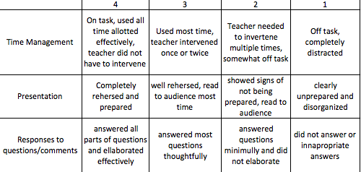

GRADE: _______

