1. What is an air mass?

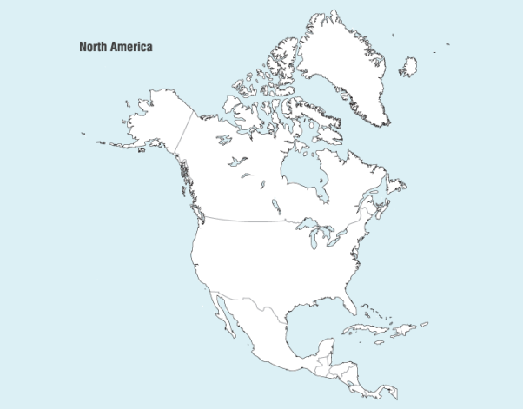
2. Identify the general air masses over Northern America in the diagram to the right.

3. Where do moist air masses come from? Dry?

4. Where do Cool/Cold air masses come from?
Warm/Hot?

5. Why are high pressure areas associated with fair weather?

6. Why are low pressure areas usually cloudy?

7. What is a front?

8. ________________________________________ sometimes occur at frontal boundaries.

9. Describe a Cold Front.

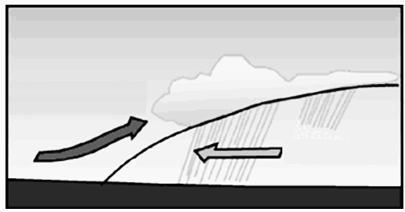

10. Label the cold and warm air masses shown in the diagram to the right of a Cold Front.

11. Explain why a cold air mass wedges under a warm air mass.

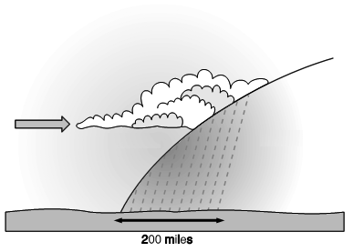
12. Describe a Warm Front.

13. Label the cold and warm air masses
shown in the diagram to the right of a Warm Front.

14. How does the temperature (density) difference between air masses affect weather?

15. Summarize in your own words how a thunderstorm forms.

16. Describe a tornado.

17. Why do large thunderstorms and tornadoes most often occur during the Spring and Summer?

18. Describe a hurricane.

19. Where do the strongest hurricanes come from and why?

