1. Explain why there is uneven heating on the Earth’s surface. ________________________
__________________________________________________________________________
2. The uneven heating of land forms ____________________________________________.
3. What causes wind? ________________________________________________________
4. Fill in the diagrams
Temperature
___________
Density
___________
Pressure
____________
Density
___________
Pressure
___________
Temperature
___________

5. Fill in the information in the diagrams below for temperature, density, and pressure. Draw an arrow to represent the direction in which the wind would blow. Why would the wind blow in that direction? ______________________________________________________________

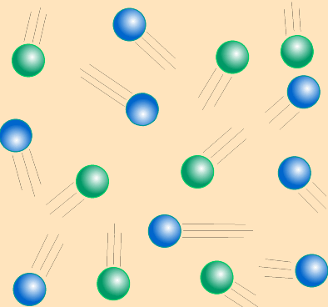
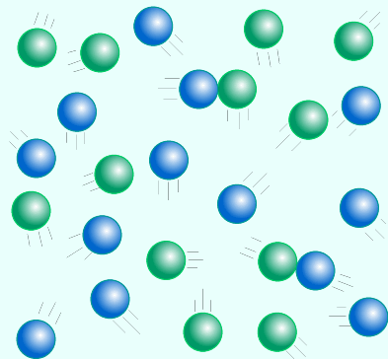
__________ Temperature
__________ Density
__________ Pressure
__________ Temperature
__________ Density
__________ Pressure

6. Describe which areas of the earth’s surface have air that is low pressure (low density). Why does the air in this area have low pressure (low density)? ________________________
__________________________________________________________________________
7. Describe which areas of the earth’s surface have air that is high pressure (high density). Why does the air in this area have high pressure (high density)? _______________________
__________________________________________________________________________

8. __________________ and ______________ cause wind and air movement.
9. What is a convection current? ________________________________________________
10. Describe an example of a convection current. __________________________________
__________________________________________________________________________
11. How does air move in a convection current? ___________________________________
12. Large convection currents are formed because of _______________________________
______________________. This produces _______________________________________.
13. How does the rotation of the Earth affect winds? ________________________________
__________________________________________________________________________
14. The flow of air caused by _____________________________ and the ______________
___________ creates distinct _______________________ on the Earth’s surface.
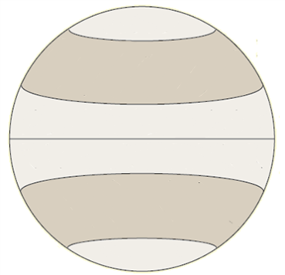
15. Draw arrows in the diagram illustrating how
the rotation of the Earth affects global wind patterns.

16. ______________________ determine the major _______________________ for the entire planet. Smaller ___________________ affect local _____________. Two such wind systems are _______________ and _________________.

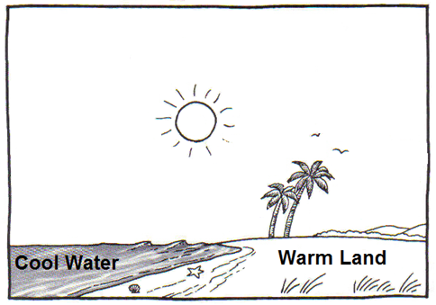
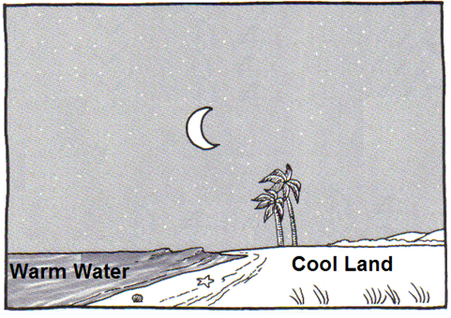
17. Label and draw the following in the diagrams below: sea breeze, land breeze, high pressure, low pressure, arrows showing the direction of the wind.

